Project Functional Plan

Assessment 2

Kieran Abelen

Contents

Objectives 2

Test approach and assumptions 2

Features and Functionality to Test 2

Expected results of Test 2

Deliverables 2

Test documentation 2

Testing procedures and Walkthroughs 2

Schedules 2

References 3

Testing Plan Functional

## Objectives

* Test all Features
* Test all Transitions between Activities
* Must be able to exit each feature

## Test approach and assumptions

I need to test every planned feature of function of the program. This document will endeavour to lay out what those are and finally how I will go about testing them.  
What are the different features laid out a simple diagram  
Can every feature be reached and can every transaction between be achieved.  
All features must be able to be exited.

## Features and Functionality to Test

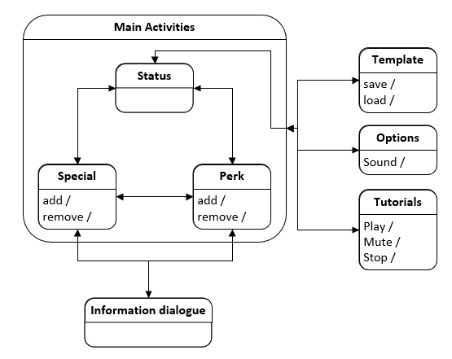

|  |  |  |  |  |  |  |  |
| --- | --- | --- | --- | --- | --- | --- | --- |
| Activity go to | Status | Special | Perks | Inform | Temp | Options | Tutorial |
| Status |  | X | X |  | X | X | X |
| Special | X | X | X | X | X | X | X |
| Perks | X | X | X | X | X | X | X |
| Inform |  | X | X |  |  |  |  |
| Temp | X |  |  |  | X | X | X |
| Option | X |  |  |  | X | X | X |
| Tutorial | X |  |  |  | X | X | X |

## Expected results of Test

|  |  |  |
| --- | --- | --- |
| Activity | Tests | Expected |
| Status | 1. Status move all available activities | 1: Navigate to Special 1: Navigate to Perks 1: Open menu and go to Temp, Options, Tutorials |
| Special | 1. Special move to all Available activities 2. Scan open information 3. Add or remove a perk | 2: Navigate to Status 2: Navigate to Perks 2: Open menu and go to Temp, Options, Tutorials 3: Open and information dialog box 4: Special can be added or removed, and page changes |
| Perks | 1. Perks move to all Available activities 2. Scan open information 3. Add or remove a perk | 5: Navigate to Status 5: Navigate to Special 5: Open menu and go to Temp, Options, Tutorials 6: Open and information dialog box 7: Special can be added or removed, and page changes |
| Inform | 1. Information dialog can leave back to Special or Perks | 8: Exited to Special 8: Exited to Perks |
| Temp |  |  |
| Option |  |  |
| Tutorial |  |  |

## Deliverables

Three Testing scenarios

1. Moving to all available navigation options
2. Adding and removing special or perks with the expected result.
3. Changing media pause, mute and volume options.

## Test documentation

# References

SageSolus. (2018, Dec 24). *What system do you play on - Results - Straw Poll.* Retrieved from www.strawpoll.me: https://www.strawpoll.me/17102854/r

Wikipedia. (n.d.). *Copyright law of New Zealand - Wikipedia.* Retrieved from en.wikipedia.org: https://en.wikipedia.org/wiki/Copyright_law_of_New_Zealand

Yetteh. (2016). *The demographics for the Fallout 4 community.* Retrieved from google.com: https://docs.google.com/forms/d/e/1FAIpQLSdWsBGm9wJz7B_GYCmfm1pHqbA9PpZS5i09yIfIg9Z7y208sg/viewanalytics